**y**

**(Badrinath / Kedarnath/ Gangotri / Yamunotri) – 11 Night & 12 Da s (Ex-Delhi)**

**CHARDHAM YATRA**

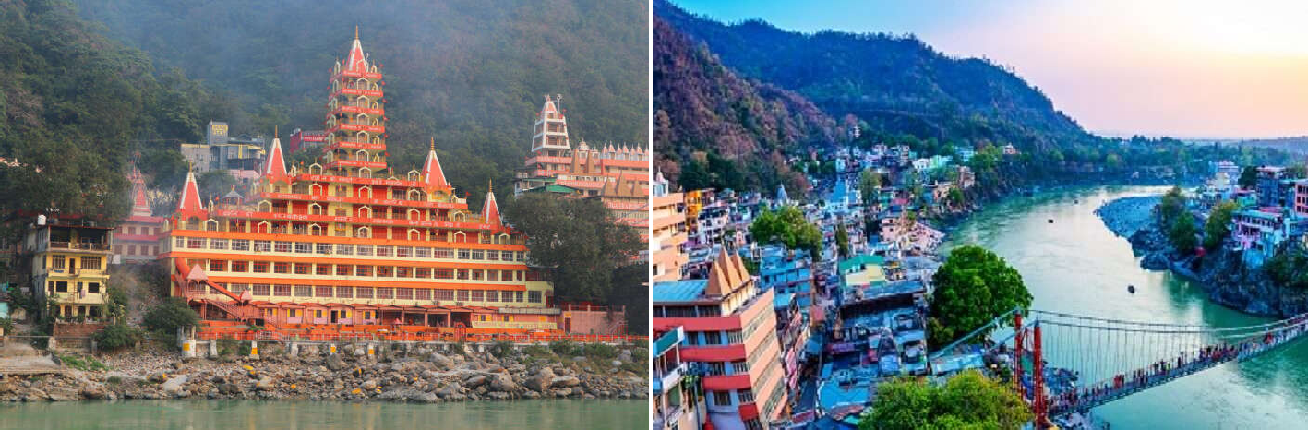

# Day 01 : DELHI – RISHIKESH (230 KMS / 06 HRS APPROX) :

Upon arrival in Delhi Airport/ Railway Station meeting and assistance with driver & Proceed to Rishikesh ,on arrival at Rishikesh check-in to hotel, evening Yatra Registration formalities & Relax.

# Dinner & Overnight stay at Hotel.

**RISHIKESH**:

24 Kms. from Haridwar, located in the laps of lower Himalayas, and is surrounded by scenic beauty of the hills on three sides with Holy Ganga flowing through it. The whole place is considered to be sacred as it is believed that meditation at this place leads to attainment of salvation. There are many temples-some ancient, some new along the river Ganges. Rishikesh is important not only as pilgrimage centre closely associated with the Ramayana, but also as home for many important centres of Hindu religious thought and spirituality, and as a very great Yoga Centre. There are many ashrams and Yoga institutes here. Rishikesh is also the gateway and the start-off point for journeys to important religious places like Badrinath, Kedarnath, Gangotri and Yamunotri.

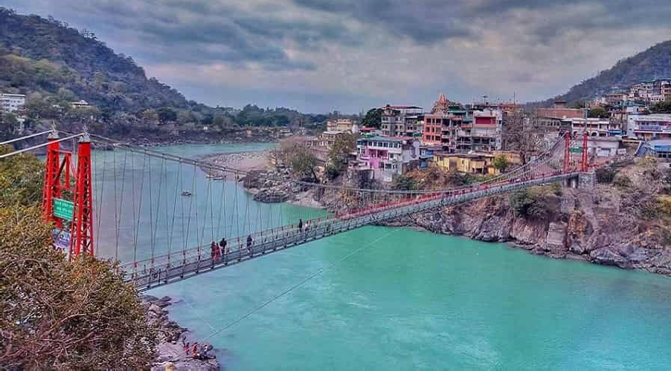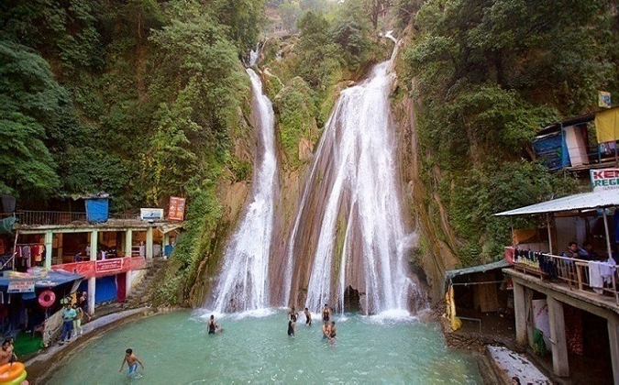

# Day 02 : RISHIKESH – BARKOT (170 Kms / 08 Hrs Approx) :

After early breakfast go for local Visit Ramjhula, Laxmanjhula & Swargaashram & drive to Barkot via Dehradun - Mussoorie En- route visit Kempty fall, reach Barkot by late evening. **Dinner & Overnight stay at Hotel.**

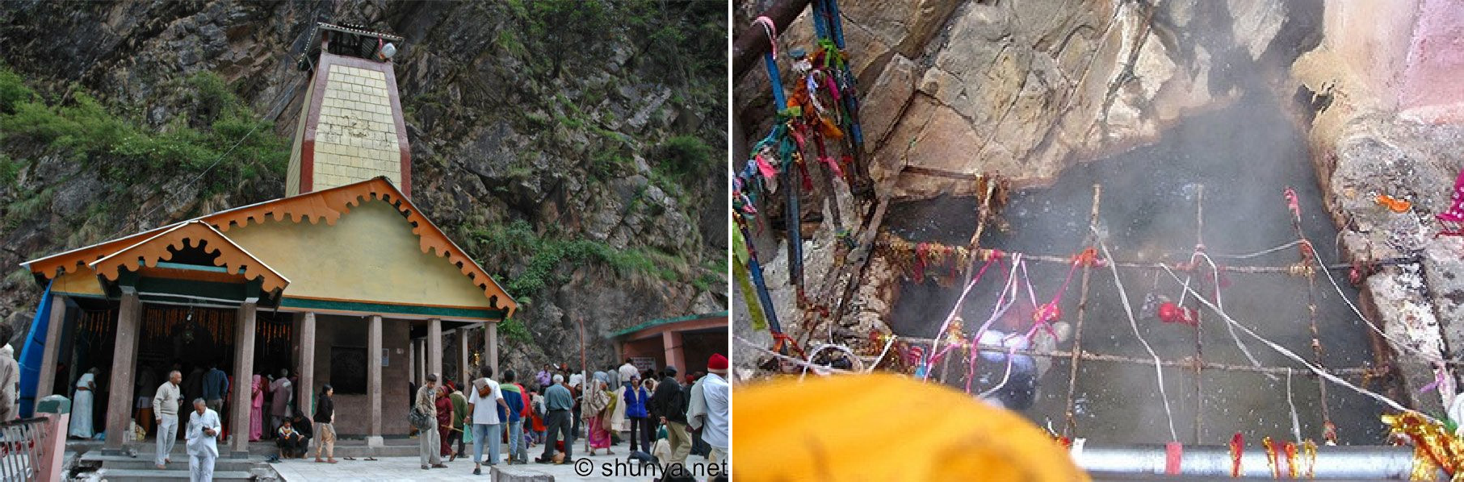

**Day 03 : BARKOT – JANKICH TI – YAMUNOTRI – BARKOT : (50 Kms Drive & 0 Kms One Way Trek) :**

**A**

**6**

After an early breakfast proceed to Yamunotri drive up to Jankichatti then 6 kms Trek (One way) to Yamunotri, here one can cook rice by packing it in a cloth and dipping it in the hot water of the hot kund. Pilgrims take this cooked rice home as "Prasad". Here near the temple

"Pooja" can be offered to

Divya Shila, after taking bath in Jamunabai

Kund and having

"Darshan" of “Yamunaji". Return back to Jankichatti & further drive back to Barkot.

# Dinner & Overnight stay at Hotel.

**YAMUNOTRI:**

Maharani Gularia of Jaipur built the temple in the 19th Century. It was destroyed twice in the

present century and rebuilt again. Yamunotri temple is dedicated to Goddess Yamuna.

Yamunotri is the source of revered river Yamuna which originates from the Champasar

Glacier lying 1 km ahead of the shrine situated at an elevation of 3235 mts. above sea level. The approach is extremely difficult and therefore pilgrims offer Pooja at the temple itself. Yamunotri was the home of an ancient sage Asit Muni. Yamuna is the daughter of the Sun just like Yama who is considered his son. It is believed that Yama would not torment any person at the time of death who takes a holy dip in Yamuna, his sister.

**SURYA KUND**:

There are a Number of thermal springs in the vicinity of the temple, which flows into numerous pools. The most important is Surya Kund.

**DIVYA SHILA**:

A rock pillar, worshiped before entering the Yamunotri Temple.

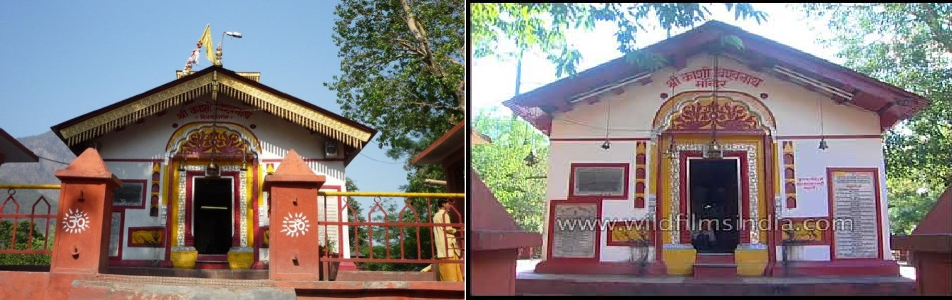

# DAY 04 : BARKOT – UTTA KASHI (100 KMS./4 HRS APPROX) :

After breakfast drive 100 kms to Reach Uttarkashi, visit Kashi Vishwanath temple. Evening free for Relax.

**R**

# Dinner & Overnight stay at Hotel

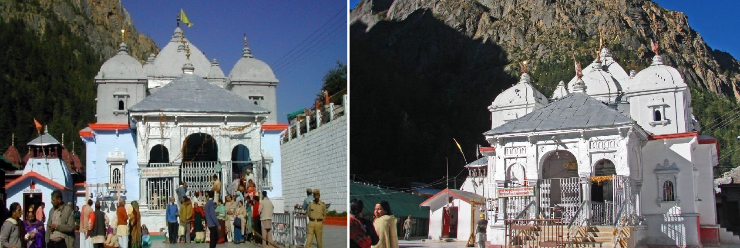

**DAY 05 : UTTARKASHI – GANGOTRI –UTTARKASHI (90 Kms / 04 Hrs. Drive One Way) :**

After breakfast leave for Gangotri early in the morning. Post offering Pooja & Darshan at Gangotri Temple & further drive back to Uttarkashi.

# Dinner & Overnight stay at Hotel

**GANGOTRI**:

Gangotri temple is 18th Century temple dedicated to Goddess Ganga. It is located near a sacred stone where king Bhagirathi worshipped Lord Shiva Ganga is believed to have touched earth at this spot. According to another legend, Pandavas performed the great "Deva Yagna" here to a tone the death of their kinsmen in the epic battle of Mahabharata. The temple is an exquisite 20 ft. high structure made up of white granite.

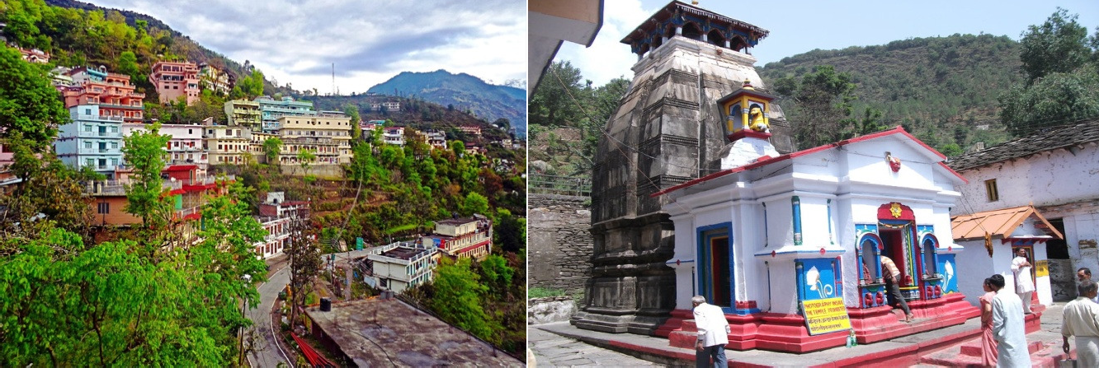

# DAY 06 : UTTARKASHI – GUPTKASHI (235 Kms./ 08 Hrs Approx) :

After Early breakfast leave for almost day long drive to Guptkashi. Reached Guptkashi at late evening.

# Dinner & Overnight stay at Hotel

**GUPTKASHI:**

Located in the Northern Himalayan belt within the Mandakini river valley, which has lush green forests. A number of streams and rivulets drain into the main Mandakini River. It has salubrious climate with its elevation being around 1,319 meters (4,330 ft.) The snow sparkling view of the Chaukhamba peak is a lovely sight to behold in the morning hours from here. The valley has large magnolia trees (locally called Champa) that provide a sweet scented atmosphere to the place. Kashi Vishwanath Temple & Ardh Narishwar Temple is Attraction point.

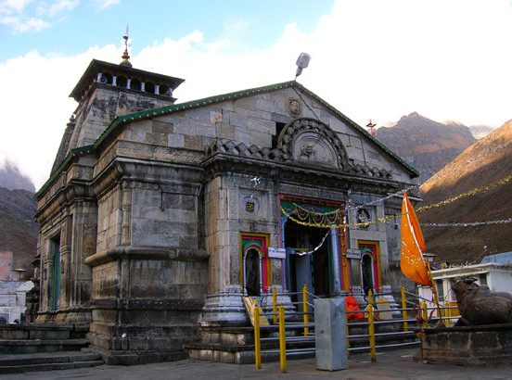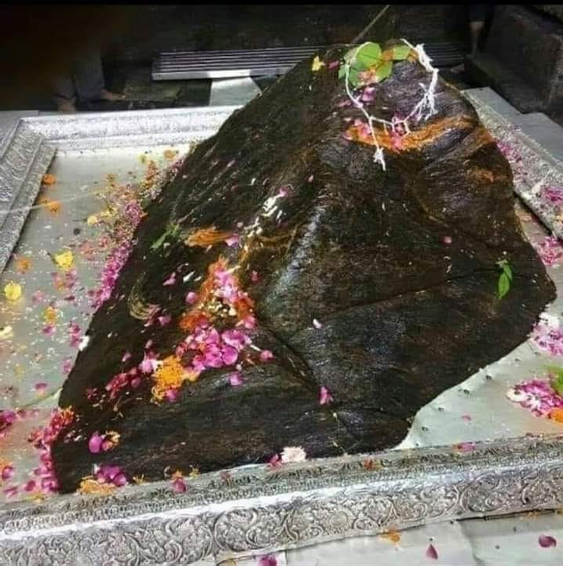

## DAY 07 : GUPTKASHI – SONPRAYAG PARKING – KEDARNATH (By Helicopter / 16 Kms .Trek) :

After early breakfast drive to Sonprayag Parking then go to Gaurikund by local sharing jeep on direct payment basis then start trek to Kedarnath ( Doli/pony options are available there on direct payment basis ), reach Kedarnath by evening , Do Darshan /Pooja at Temple.

# Dinner & Overnight stay at Guest House.

**KEDARNATH :**

The present temple built in 8th Century A.D. by Adi Guru Shankaracharya lies adjacent to the site of an ancient temple built by Pandavas. The temple has a conical lingam - the main idol, a statue of Nandi - the celestial bull, a 'GarbaGrah' for worship and a man dap for assemblies of pilgrims and visitors. The temple is more than 1000 years old.

## Note : Heli Ticket will be subject to availability & operation by the heli services on extra cost. If not available, then guest will go Kedarnath by Doli / Ponny (at your own cost by direct payment basis).

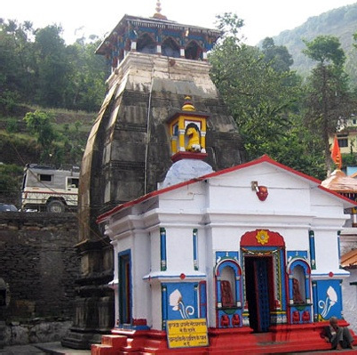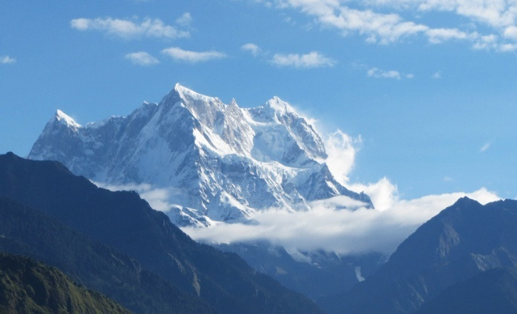

**DAY 08 : KEDARNATH – SON RAYAG PARKING - GUPTKASHI (30 KMS./02 H S APPROX) :**

**P**

**R**

After breakfast start same down trek to Gaurikund then back to Sonprayag Parking by same local sharing Taxi & drive back to Guptkashi. Evening free for Relax.

# Dinner & Overnight stay at Guptkashi.

**M**

**X**

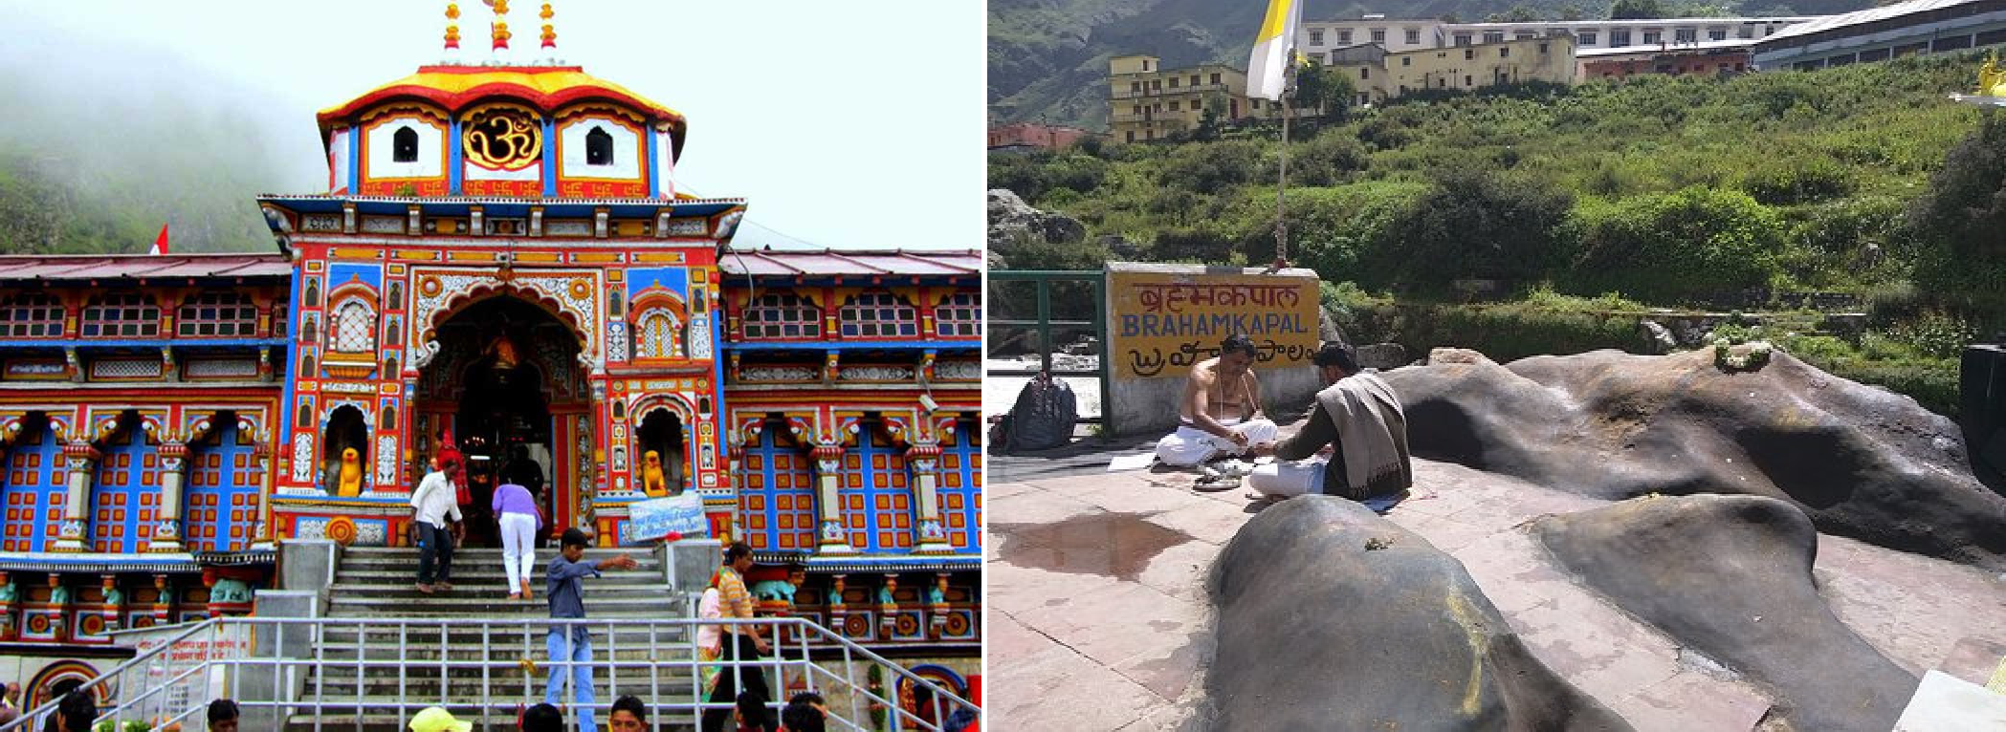

## DAY 09 : GUPTKASHI -JOSHI ATH – BADRINATH (180 KMS./07 HRS APPRO ) :

After Breakfast leave for Badrinath En-route visit Narsingh Temple, and Adi Shankracharya Samadhi at Joshimath, then drive to Badrinath. On arrival check in to hotel, later visit Vyas Cave, Ganesh Cave, Bhim Bridge & origin of River Saraswati at Mana village the last village before the Tibetan border, later go to temple for holy Darshan/ Pooja & attend evening Arti.

# Dinner & Overnight stay at Hotel

**BADRINATH:**

Cradled in the twin Mountain ranges of Nar and Narayan is the holiest of the four main shrines - Badrinath along the left bank of river Alaknanda with the towering Neelkantha Peaks as the splendid backdrop. Once the spot was carpeted with 'badris' or wild berries and hence was famous as Badri van. Legend has it, when the Ganga was requested to descend to earth to help suffering humanity; the earth was unable to withstand the force of its descent. Therefore, the mighty Ganga was split into 12 holy channels. Alaknanda was one of them that later became the abode of Lord Vishnu or Badrinath.

**NARAD KUND:**

A recess in the river, near Tapt Kund, forming a pool from where the Badrinath idol was recovered.

**BRAHMA KAPAL:**

It is a flat platform a few yards north of the temple and on the bank of river Alaknanda. It is an important place for Shraddha ceremony or offering of pinds to ensure a heavenly place for dead ancestors or manes. It is said that offering pind here, the manes are permanently enshrined in heaven and no more pinds are to be done elsewhere ever afterwards. Legends have it that when Shiva chopped of the fifth head of Brahma, it got stuck to his trident. Lastly with the blessing of Lord Vishnu at Badrivan, the head of Brahma fell down from the trident at this place & hence the name Brahma- Kapal (head).

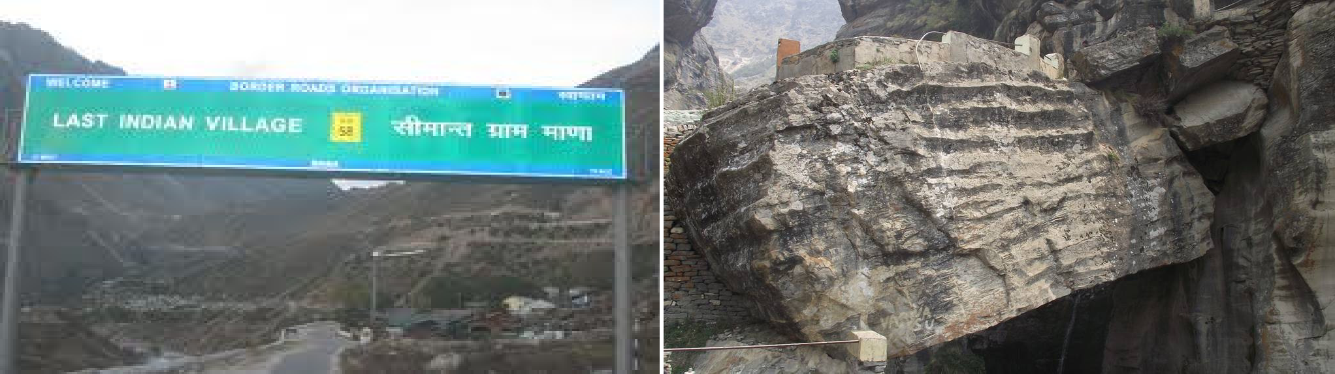

**MANA VILLAGE**:

Inhabited by an Indo-Mongolian tribe, it is the last Indian village before Tibet. The women of the village offer Choli to the deity on closing day of the temple each year.

**BHIM PUL:**

On the other side of Mana village, a massive rock forming a natural bridge lies over the roaring Saraswati River. It presents a spectacular view of water thundering down through the narrow passage under the rock and is believed to have been placed there by Bhim, the second eldest among the five Pandava brothers.

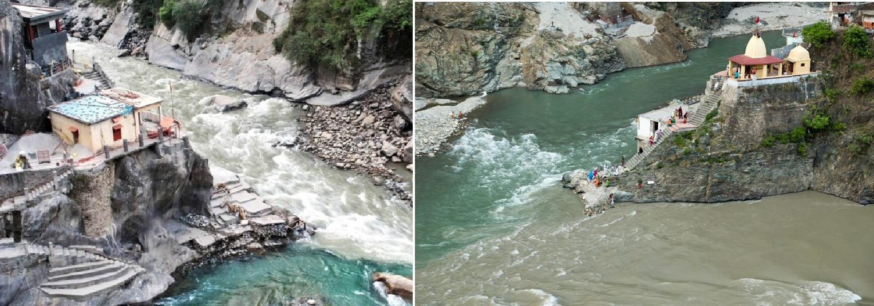

# DAY 10 : BADRINATH – SRINAGAR (190KMS./05-06 HRS APPROX) :

Early Morning Mahaabhishek Pooja (optional, which will be booked day before) after breakfast drive to Srinagar En-route visit Vishnuprayag, Karnprayag, Nandprayag & Rudraprayag. Reach Srinagar by late evening.

# Dinner & Overnight stay at Hotel

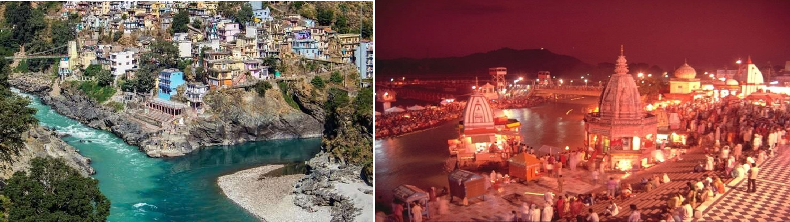

## DAY 11 : SRINAGAR – HARIDWAR (135 KMS /05 HRS APPROX) :

After breakfast drive to Haridwar en-route visit Devprayag, (The Confluence of River Alaknanada & Bhagirathi) to become Ganga. Reach Haridwar in the afternoon, check in to hotel, later visit Mansa Devi, Chandi Devi Temples & Evening attend Famous Ganga Arti at Har ki Pauri.

# Dinner & Overnight stay at Hotel

**HARIDWAR:**

Haridwar, lying at the feet of Shiva's hills, i.e. Shivaliks, in the Haridwar district of Uttarakhand. Suryavanshi prince Bhagirathi performed penance here to salvage the souls of his ancestors who had perished due to the curse of sage Kapil. The penance was answered and the river Ganga trickled forth forms Lord Shiva's locks and its bountiful water revived the six y thousand sons of king Sagar. In the traditional of Bhagirathi, devout Hindus stand in the sacred waters here, praying for salvation of their departed elder. It is doorway to the sources of the Ganga and the Yamuna, 3000 to 4500 meters up into the snowy ranges of the central Himalayas. The 'Aarti' worship of the Ganga after sunset and the floating 'dia' (lamp) is a moving ritual.

## DAY 12 : HARIDWAR - DEL I (218 KMS / 06 HRS APPROX) :

**H**

After breakfast, leave for Delhi Airport / Railway Station & drop for onward journey.

**A**

**e**

**p**